KONTROLNI LIST PRED NAKLADANJEM NEVARNEGA BLAGA – V KONTEJNERJU
CHECK FORM BEFORE LOADING DANGEROUS GOODS – IN CONTAINER
Ta del obvezno izpolni vsak naročnik – organizator prevoza nevarnega blaga v kontejnerjih, tank kontejnerjih, tudi v omejenih količinah (majhnih embalažnih enotah) (3.4 ADR).
This part must be filled out by each contracting party organising the transport of dangerous goods in containers, tank containers, also in limited quantities (small packaging units) (3.4 ADR).
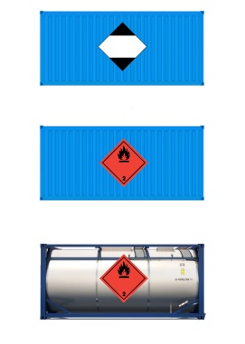 |  | Naročnik
 |  | Customer / Client
 |  | Registrska št. vozila / priklopnika
 |  | Registration no. Vehicle / trailer
 |  | Voznik (ime in priimek)
 |  | Driver (name and surname)
 |  | Količina naloženega nevarnega blaga |  | PO SPREMLJAJOČI DOKUMENTACIJI
 |  | Quantity of loaded dangerous goods |  | ACCORDING TO ACCOMPANYING DOCUMENTATION
 |  | Razpolagamo s prevozno listino v kateri je navedeno nevarno blago  We have a transport document in which dangerous goods are stated |  | ☐ |  |  | Da  Yes
 |  |  |  | ☐ |  |  | Ne – blago se prevaža v omejenih količinah  No - the goods are carried in limited quantities
 |  | *UN številke blaga ali ostankov blaga
 |  | UN numbers of goods or residues of goods
 |  | *Številke nalepk nevarnosti
 |  | Danger labels/placards numbers
* Navedite vse UN številke in številke nalepk nevarnosti. V primeru prevoza nevarnega blaga v omejenih količinah vpiši »LQ« v polje številka nalepke nevarnosti.
Write down all UN numbers and danger labels/placards numbers. In the case of transport of dangerous goods in limited quantities, put "LQ" in the danger labels/placards field.

Ta del obvezno izpolni vsak naročnik – organizator prevoza nevarnega blaga, razen prevoza nevarnega blaga v omejenih količinah.
This part must be filled out by every contracting party organising the transport of dangerous goods with the exception of the transport of dangerous goods in limited quantities.
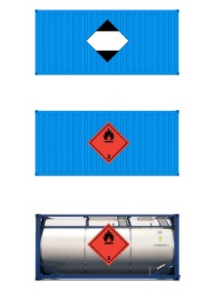 |  | Voznik ima veljaven certifikat ustrezne kategorije za prevoz tega nevarnega blaga  The driver holds a valid certificate of appropriate category for the carriage of this dangerous goods |  | ☐ |  | Da  Yes
Ta del obvezno izpolni vsak naročnik – organizator prevoza v tank kontejnerjih.
This part must be filled out by every contracting party organising the transport in a tank container.
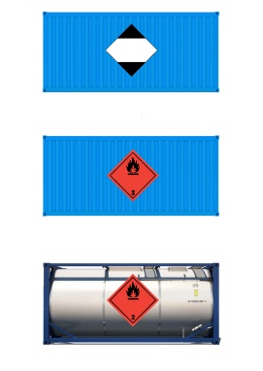 |  | Veljavnost certifikata za vozilo
 |  | The validity period of the vehicle certificate
 |  | Veljavnost certifikata za priklopnik
 |  | The validity period of the trailer certificate
Izpolni voznik
This part of the form is filled out by the truck driver
Potrjujem, da vozilo in prikolica v vseh pogledih ustrezata zahtevam za prevoz nevarnega blaga (oprema vozila, oranžne table, nalepke nevarnosti). V kabini vozila so pisna navodila po ADR. Sočasno se zavezujem, da če bom pri prevzemu nevarnega blaga opazil pomanjkljivosti, bom na to takoj opozoril zaposlene na kontejnerskem terminalu.

I certify that the vehicle and trailer in all aspects meet the requirements for the transport of dangerous goods (vehicle equipment, orange plates, dangeros goods placards). There are instructions in writing according to ADR in the cabin of the vehicle. At the same time, I undertake that if I notice any deficiencies on the dangerous goods received, I will immediately warn the employees of the container terminal.
Kraj in datum
Place and date |  |  |  |  | Ime, priimek in podpis voznika  Name, surname and signature of the driver

